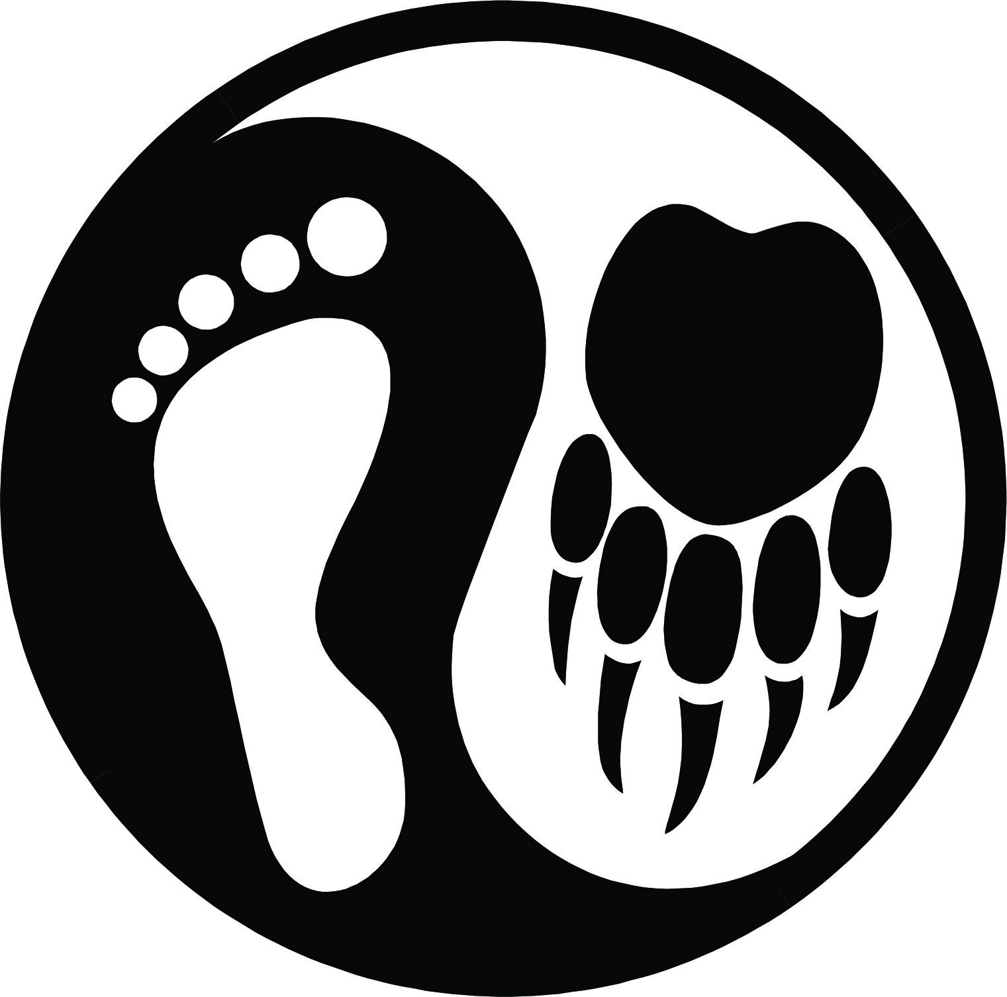
Nature’s Tracks
~Forest Play Programs~

Participant Information and Registration Package
2013

Please read carefully, complete and return to us via email to hold your spot. Waivers can be signed on the first day of the session or signed, scanned and emailed back to us.

Contacts:

Group Leaders:
Dave Verhulst: 403-678-1810 (home)
403-760-9288 (cell);
ntforestplay@gmail.com

Corey Stevens: 403-675-2011(home)
403-953-0052 (cell)
icr8river@yahoo.ca
Owner of Nature’s Tracks (also known as: EcoYoga Adventures): Ronna Schneberger; Ronna@ecoyoga.ca
Hello!

Thank-you for registering your child for our Forest Play Program! We’re excited about sharing some fun experiences in the forest with your children.

Our philosophy for our Forest Play programs has evolved through years of experience working with children, youth and adults in wilderness areas and parks, studying nature connection mentoring, and through our own experiences as parents of young children. Positive experiences in nature can heighten our children’s natural curiosity, awe and wonder. Through play, stories, natural living skills and the art of observation, listening and questioning, we aim to nurture positive relationships with all life.

We’ve put this Information and Registration Package together to provide you with some important information and to ensure we have the information we need to help your child have a safe and fun experience with Forest Play. We respect your privacy and will not share any of the information you provide with any other parties.

What to Bring:
- Snacks and water (note: at least 500 ml of water is recommended). Please ensure that you pack enough snacks for an afternoon of playing outdoors!
- Clothing appropriate for the weather. We will be outdoors in all kinds of weather. Please monitor the weather, dress your child in layers and always pack extra layers for your child as the weather can change a lot over the course of a day.
Items to pack and/or wear will depend on the season. Here is a general list:
- Rain gear (pants and jacket)
- Touque
- Mittens or gloves
- Coat/Fleece
- Sturdy footwear (boots in winter or sturdy running/hiking shoes in fall and spring. NO SANDLES or CROCS please!)
- Sunhat/sunscreen
- Personal Medications (if needed)
- Daypack – a size comfortable for your child to carry for the afternoon (we’ll be moving from spot to spot, so there will be opportunities to put it down while we are playing games or doing camp craft activities).

If you have any questions or reservations about what items to bring, give us a call and we can offer advice or possible alternatives.

Thank-you for registering your child and for taking the time to read and fill out the forms included in this package. We will have copies of the waiver form available on the first day for you to sign. We’re looking forward to seeing you and your child!

Dave Verhulst & Corey Stevens

Nature’s Tracks Forest Play
Child & Youth Participant Registration Form

Name of Program:____________________________

Date(s) of Program: ___________________________

First Name: _______ Last Name:__ (participant)
Cost of Program $
Contact Name for Parents/Guardians: _____________________________________________________
Address ______________________________________________________________________
City__________________ Province______________ Postal Code__________
Home Phone ( ) ____________ Work ( ) _____________ Other ( )____________
Fax ( ) ____________________ Email __________________________
Has participant attended previous Forest Play Programs lead by Dave, Corey or Ronna? Yes / No

Will you permit photos and/or video to be taken of the participant and displayed or used for promotions by Nature’s Tracks? Yes / No

Are you willing to participate in surveys for program evaluation? Yes / No

Parent or Legal Guardians Full Name _________________________________________
Address ______________________________________________________________________
City Province Postal Code
Home Phone ( ) ____________ Work ( ) _____________ Other ( )_____________
Fax ( ) ____________________ Email __________________________

Please sign to approve photo and survey use of participant:

Parent/Legal Guardian Signature: _________________________________________

Cancellation Policy:
If the program is cancelled by Nature’s Tracks for any reason, a full refund will be provided. If you cancel your registration 2 weeks ahead of time, a full refund will be provided minus a $25 administration fee. If you cancel within 2 weeks, no refund will be provided.

2
Nature’s Tracks Youth Medical Disclosure Form
(To be filled out by Parent or Legal Guardian Only)

The information in this form is used to ensure the safety and comfort of participants.
The form should be filled out by the parent/legal guardian of the participant. It is important for program staff to have accurate information when making decisions in the field.

Participants Name: ________________________________________________
Male □ Female □

Date of Birth: _____________ Age: ___________ Height: ________ Weight: ________

Health Care #:___________________________________ Province _________

IN CASE OF AN EMERCENCY PLEASE CONTACT:

1. ________________________________ (Name) Relationship:____________________

Phone:
Day: ____________________ Night: _____________________ Other: _____________

2. ________________________________ (Name) Relationship: ____________________

Phone:
Day: ____________________ Night: _____________________ Other: _____________

Does the participant wear eye glasses? Yes / No Contact Lenses? Yes / No

Can the participant swim? Yes / No Has the participant ever had frostbite? Yes / No

Is the participant currently taking any medications? Yes / No

If Yes, please fill out the following for the participants’ safety:

Name of Medication(s) and Dosage(s)/Time Taken for each:
___________________________________________________________________________________________________________________________________________________________________________________________________________________________

What is the medication(s) for?
________________________________________________________________________________________________________________________________________________

Does the participant have any allergies? Yes / No

If Yes, please indicate known triggers, type and severity of reaction, and medications used:
___________________________________________________________________________________________________________________________________________________________________________________________________________________________________________________________________________________________________

Has the participant ever had anaphylaxis? (A severe and prolonged reaction to allergies)

Yes / No

If Yes, when, how often, and what is the trigger?
____________________________________________________________________________________________________________________________________________________________________________________________________________________________________________________________________________________________________

Does the participant have any injuries or disabilities? Yes / No

If Yes, please explain:
___________________________________________________________________________________________________________________________________________________________________________________________________________________________
Does the participant have any chronic (ongoing) medical conditions? (e.g. asthma, diabetes, epilepsy) Yes / No
If Yes, please explain:
___________________________________________________________________________________________________________________________________________________________________________________________________________________________

Does the participant have any dietary restrictions? Yes / No

If Yes, please explain:
___________________________________________________________________________________________________________________________________________________________________________________________________________________________

By signing below you agree to allow Nature’s Tracks field staff to administer routine and emergency medical treatment to the participant, and to contact emergency medical services if needed. All staff are trained in Wilderness First Aid (minimum 40 hrs course)

I, _________________________________________ (Parent or Legal Guardian)
(Print Name)

Declare that the information in this medical form is accurate to the best of my knowledge. I acknowledge that providing inaccurate information may endanger my child or others.
(Must be signed by Parent/Legal Guardian of minors)

Signed (Parent/Legal Guardian) ________________________________________________

Date signed: _______________________
(D/M/Y)
Phone number: ( ) ________________

Nature’s Tracks/EcoYoga Adventures
Parental Agreement Form Release of Liability, Waiver of Claims and Assumption of Risks

Please read carefully. By signing this form you will waive certain legal rights. This form must be signed in ink by the parent or legal guardian of the participant. If you have any questions or concerns regarding the statements below, please discuss them with staff before signing.

Participant’s Name:____________________________________________________

Definition – In this agreement, the terms “Forest Play” or “Program” refer to a wide range of outdoor activities that may include any combination of the following: active games, camp craft, day hiking in mountainous terrain in all seasons, group initiative activities,
(e.g. cooking, carrying wood/water, wood carving), and other outdoor activities carried out in natural areas. I am aware that there are certain risks inherent in my child’s participation in these activities some of which include:

- Weather. Extreme weather conditions (including storms and lightening) or sudden changes may be experienced
- The possibility of becoming separated from staff and other participants
- Steep, uneven, slippery or otherwise hazardous terrain. Slips and falls contribute to many outdoor accidents.
- Dangerous animal encounters (including bears and cougars), insects and poisonous plants,
- Water. Rivers and lakes have many hazards which can include rapid level changes, cold or fast moving water, man-made and
natural objects in the water, rapids, high waves and thin ice.
- Falling objects encountered while in mountainous and forested terrain, including tree fall & rock fall.
- The conduct of other participants

I acknowledge that although the program may take precautions to reduce the risks and increase the safety of activities, all dangers and risks cannot be foreseen or managed. I understand and voluntarily accept without limitation, all risks, including the possibility of loss of property, unforeseen expenses, personal injury (including death) associated with my child’s participation in the program. I acknowledge that the value of the Forest Play program derives in part from activities carried out in natural areas and that the inherent risks of such activities contribute to their value.

I authorize program staff to obtain and provide such medical advice and services as they deem necessary for the health of my child. In respect to medical services which require the consent of a parent/guardian, I authorize program staff to provide such consent. I accept financial responsibility for all medical costs which exceed coverage provided by my health care plan.

I waive all and any claims that I may have, and release from all liability and agree not to sue Program employees, directors, independent
or sub-contractors and volunteers (collectively the “Personnel”) for any loss, property damage, expense, personal injury (including
death) that may result from my child’s participation in the Program.

As a parent, I believe that my child’s participation in the program and this parental agreement form are, on the whole, beneficial to my
child. I agree to hold harmless and indemnify the Program and its Personnel for all and any loss, damage, expense or personal injury
(including death) experienced by my child as a result of my decision to enroll my child in the program.

I have carefully read and understand this form.

Signed this________________________day of_____________________20____________
(Day) (Month) (Year)

Name of Parent/Legal Guardian: ________________________ and ________________________________
(Print) (Print)

Parent / Legal Guardian Signature: ______________________________________

Witness name: ___________________________________________________

Signature of Witness: _____________________________________________

Address of Witness: ______________________________________________

